ABSTRACT TITLE
Goodenough, D.^{a*}, Schönbein, C.^{b}, Scheele, C.W.^{c}, Staudinger, H.^{a,b,c}
ª Name of the institution, laboratory, city
*e-mail of presenting author

The abstract shall not exceed a maximum of one A4 page maximum (references included). Calibri font (size 11) shall be used, with justified text and margins of 2.5 cm. One figure (or table) at most can be included below the text. The file size shall not exceed 2 MB.
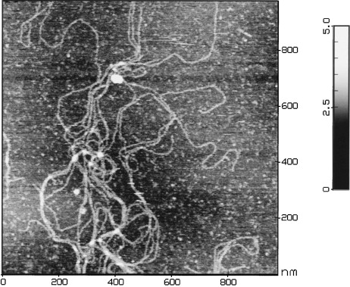
Figure 1. Insert the legend right below the figure (Calibri 11) [1].
References are listed at the end of the document with Calibri font (size 10)
[1] Journal articles: I. Capron, S. Alexandre, G. Muller, Polymer 23 (1998) 5725-5730.
[2] Books: G.D. Fasman, Circular Dichroism and the Conformational Analysis of Biomolecules, First Edition, Springer Science, 527-532.
[3] Patents: CA patent 2194797 (2010), J.P. Behr, B. Demeneix, F. Lezoualch, M. Mergny, D. Scherman, O. BOUSSIF (invs.)

